**S3 Bucket Versioning Assignment**

**Problem Statement: You work for XYZ Corporation. Their application requires a storage service that can store files and publicly share them if required. Implement S3 for the same.**

**Tasks To Be Performed:**

**1. Enable versioning for the bucket created in task 1.**

**2. Re-upload any 2 files already uploaded to verify if versioning work**

1. Enable versioning for the bucket created in task 1.

Go to properties and enable versioning and save change

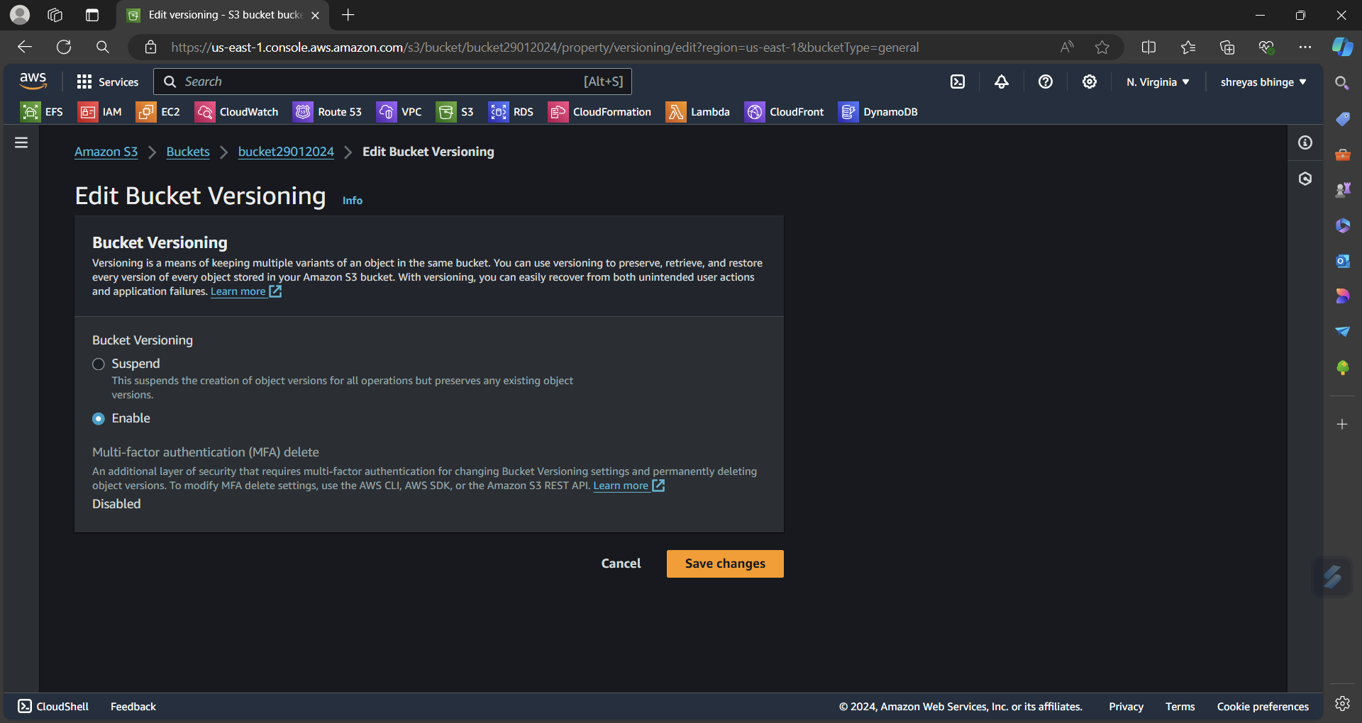

2. Re-upload any 2 files already uploaded to verify if versioning work

Re-uploaded 2 file

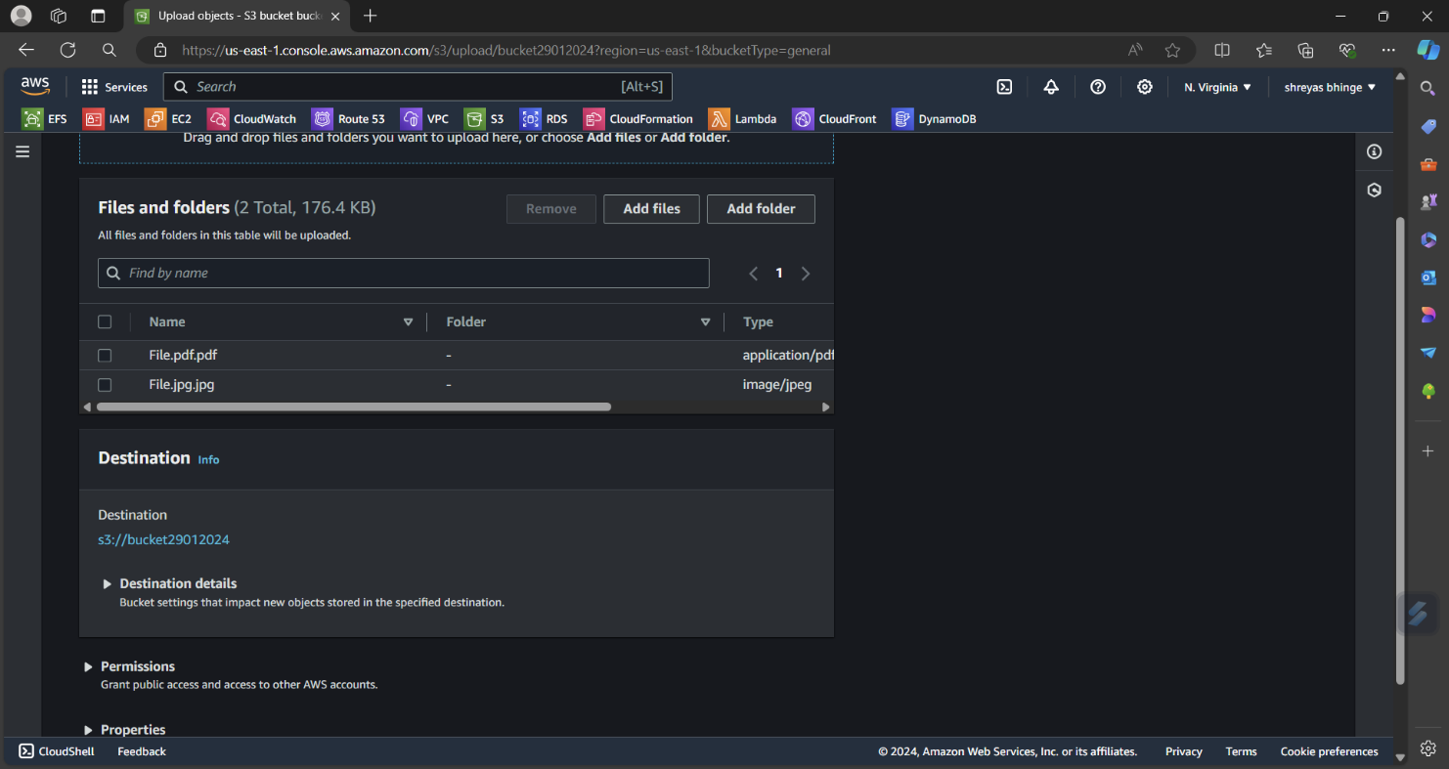

Enabled show versioning

